**1, Install theCSR BlueSuite 2.5.8 software on your PC：**



2, Connect Avantree Oasis to PC via Avantree micro USB cable (included)

Power on, Press both  and  button for 8S until all LED indicators are off.

3, Upgrade Oasis to software v32.3

3.1 Please find“ CSRBlueSuite 2.5.8”from“all programs” on your computer and select: DFUWizard” and click

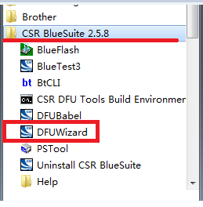

Click Next

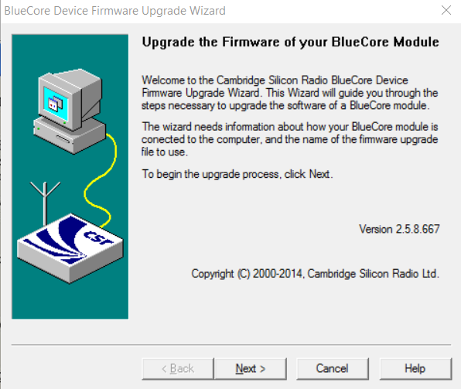

Choose “ Universal Serial Bus(USB)” and Click Next

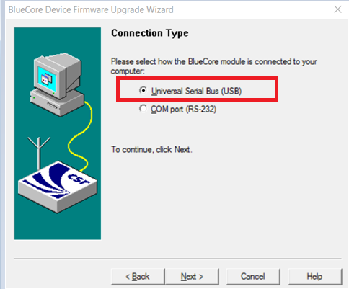

Select the second one as below and click Next directly.

NOTE: Please don’t select the first one and don’t click” change” to back up as it may cause firmware corrupt.

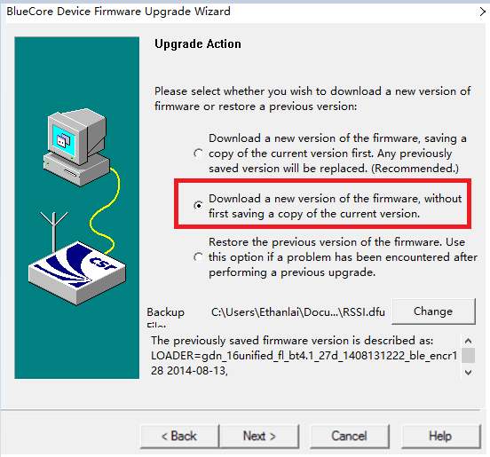

Click “Browse” and select “BTR023-v32.3.dfu” and click Next

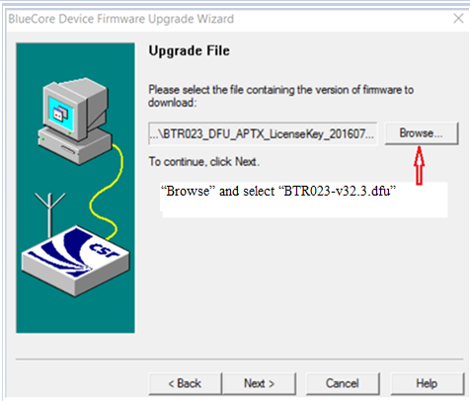

Click Next

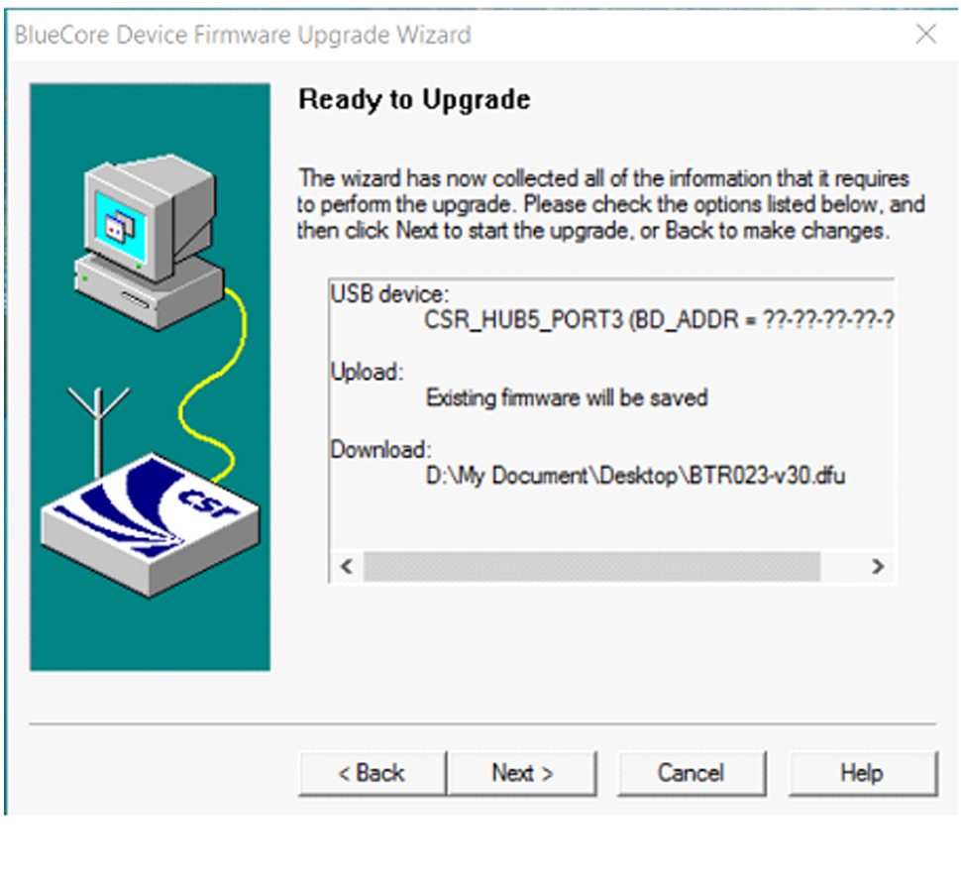

Waiting for upgrading

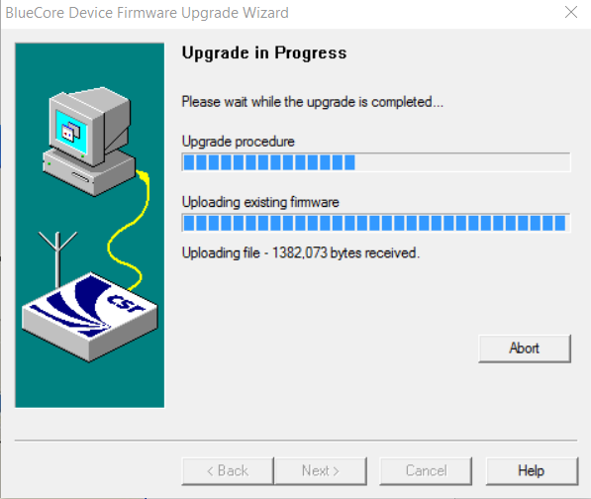

After successful upgrade, click Finish as below.

At the same time, Avantree Oasis will automatically power on. Then it is ok and you can use.

